Date access: 2020-03-09

<http://wjw.beijing.gov.cn/wjwh/ztzl/xxgzbd/gzbdyqtb/202001/t20200130_1621747.html>

From 12:00 on January 28th to 12:00 on 29th, 11 new cases of pneumonia infected with new coronavirus were added in this city

Date: 2020-01-29 Source: Beijing Municipal Commission of Health

         From 12:00 on January 28th to 12:00 on 29th, 11 new cases of pneumonitis infected with new coronavirus were reported in this city, 7 had contact history in Hubei and other provinces, 7 were close contacts of confirmed cases, and 1 was not completed Epidemiological investigation, 4 of them had close contact with both Hubei contact history and confirmed cases. All have been sent to municipal designated medical institutions for treatment.

As of 12:00 on January 29, the city has accumulated 102 confirmed cases. 2 cases in Dongcheng District, 9 cases in Xicheng District, 19 cases in Chaoyang District, 23 cases in Haidian District, 8 cases in Fengtai District, 2 cases in Shijingshan District, 1 case in Mentougou, 7 cases in Tongzhou District, 2 cases in Shunyi District, 10 cases in Daxing District, There were 8 cases in Changping District, and 11 cases came from overseas. No cases have been found in Fangshan District, Pinggu District, Huairou District, Miyun District, and Yanqing District.

**1月28日12时至29日12时，本市新增11例新型冠状病毒感染的肺炎病例**

日期：2020-01-29 来源：北京市卫生健康委‍

         1月28日12时至29日12时，本市新增11例新型冠状病毒感染的肺炎病例，7例有湖北及其他省份接触史，7例为确诊病例的密切接触者，1例尚未完成流行病学调查，其中4例既有湖北接触史又是确诊病例的密切接触者。均已送至市级定点医疗机构进行救治。

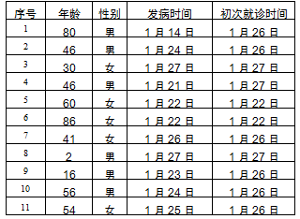

        截至1月29日12时，本市累计确诊病例102例。其中东城区2例、西城区9例、朝阳区19例、海淀区23例、丰台区8例、石景山区2例、门头沟1例、通州区7例、顺义区2例、大兴区10例、昌平区8例，外地来京人员11例。房山区、平谷区、怀柔区、密云区、延庆区尚未发现病例。